Welcome To
Kirktonholme Primary School Nursery Class 2019/20



Nursery Handbook


Kirktonholme Primary School
Nursery Class

Welcome

We are delighted that you have chosen Kirktonholme Primary School Nursery Class as your child’s nursery placement. The nursery team look forward to working with your family to ensure that your child is safe, healthy, achieving, nurtured, active, respected, encouraged to be responsible and feel included in all aspects of nursery life.

We occupy a superb campus geared specifically to engage our children in learning through a wide variety of learning experiences following Curriculum for Excellence and South Lanarkshire Council guidelines.

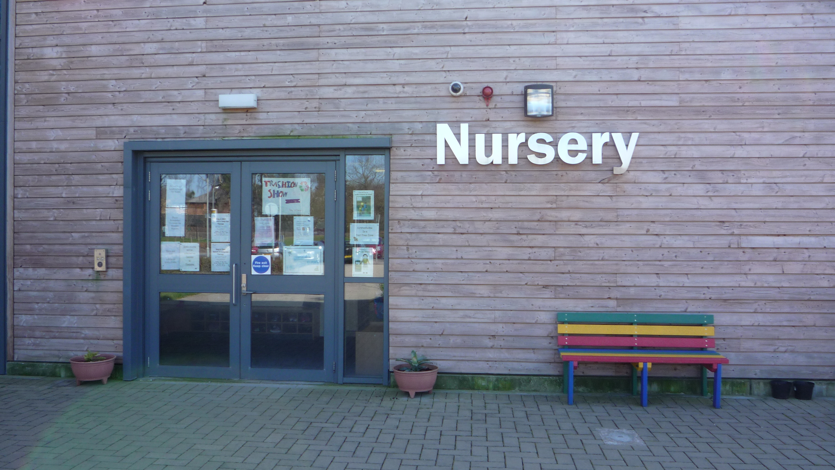

Staff Team

Heads of Establishment – Mrs Linda Wright

Depute Head Teacher – Mrs Karen Clow

Nursery Teacher and school Principal Teacher – Mrs Kim McCaig

Early Years Staff – Mrs Karen Moran(Team Leader), Mrs Fiona Thorpe, Mrs Kim Young, Miss Abby McKendrick, Mrs Mirza Watt, Mrs Andi Murray and Mrs Nicole Lynch.
We have a Modern Apprentice Miss Tanya Sutherland and a vacancy for an Early Years worker Thursday and Friday

Students from various colleges and universities have placements within the nursery throughout the year.

Opening Times

The nursery is located within the Kirktonholme Primary School Campus building.

It has its own separate entrance and car parking facilities.

Morning Session 8.45am– 11.55am (Doors will be opened from 11.45am onwards)

Afternoon Session 1.00pm – 4.10pm (Doors will be opened from 4.00pm onwards)

Nursery Year

The nursery observes the same term times as the primary school. There are four terms in the year. Holiday dates are given to all families at the start of each session and are available from the school office and on South Lanarkshire Council’s website (details can be found at the end of this handbook).

Nursery Capacity

Our nursery has the capacity for 40 pupils in each session which includes three, four and five year old early learners.

Links to the schools and Community

Mrs Karen Clow, Depute Head Teacher (DHT), has responsibility for the Early Level – Nursery/Primary 1 with Mrs Linda Wright, Head Teacher, having overall responsibility for the whole school.

Nursery and Primary One staff work closely together to promote the smooth transition from nursery to primary school.

The DHT and Nursery Teacher liaise both with additional nurseries of children registering to start school at Kirktonholme and with schools where Kirktonholme Nursery children move onto. Staff are invited to visit and meet the child(ren) informally and meet with nursery staff.
DHTs, Nursery Teachers and Team Leaders within the Learning Community hold regular planned meetings to discuss the curriculum and to share good practice.

Our nursery children attend weekly celebration of achievement assemblies, planned religious observance assemblies and are included in Head Teacher, Gold Board and Star Writer Awards.

Children are encouraged to bring in achievements earned outside of nursery, so we can celebrate their successes in nursery.

As part of Curriculum for Excellence the nursery has visits from the Oral Educator, the
Fire and Rescue Service, the Police as well as any other specialists, that have been identified by pupils and staff, who may be able to enhance our learning experiences. If any families feel that they could offer their skills to the nursery at any time please speak with a member of staff.

In addition to the above we have business links with Morrisons at Lindsayfield and a community link with McKillop Gardens Care Home.
We have an educational visit to Low Waters Museum in December.
Snack
Our children are all offered a nutritious snack each session based upon national nutrition advice. Information regarding snack can be found daily on the door entering the playroom. There is a fee for snack set by South Lanarkshire Council at 50p per day. The school is moving to an online Parent Pay system and you will get details when your child starts nursery. If any family feels that this will put a financial strain on them, please speak confidentially to Mrs Clow, Mrs Wright, Mrs Moran or Mrs McCaig.
Any surplus funds left over from snack are used to buy resources to enhance learning opportunities in our nursery and support events throughout the year.
We thank you for your support.

Coming to Nursery
- Entrance is through the main nursery door.
- Secure entry is manned by the Nursery Teacher or Team Leader.
- Parents/carers help their child to change shoes, hang coats up, encouraging independence where possible, and escort them into the nursery where signing in takes place.
- Signing in is recorded on group coloured clip boards.
- Please sign in the first space and cross below if the same person is collecting. Where another person is collecting please print their name in second space.
- Once your child is settled you will exit by the front door of the nursery.
- Parents/carers bringing prams or buggies should leave them outside the nursery entrance. A member of staff on the door will be there. If you do not want to leave your baby or toddler outside you may carry them into the nursery.
- Older siblings should wait outside the nursery with the member of the team on door duty.
- A named bag containing a change of clothes should be placed on pegs and taken hoe at the end of each nursery session.
- Indoor shoes may be left in your child’s basket in nursery.
- Collection of children is through the main nursery entrance from 11.45am/4.00pm.
- Complete the signing out sheet and your child will be brought to you.
- Should your child require to use the toilet on arrival or departure from the nursery, this would be the responsibility of a member of staff. Parents do not have access to the children’s toilets. You may use the toilet in the entrance hallway with your child.

Clothing
There is a nursery uniform provided by Academy Uniforms – a red polo shirt and sweatshirt with the school logo and order forms are available from the school office throughout the year.
The children should be dressed in comfortable clothes which allow them freedom to participate in the various play activities.
Each child has a peg to hang up outdoor jackets and a bag with a change of clothing.
Outdoor waterproof playsuits are provided for the children.
Please label all your child’s belongings.

Promoting Positive Behaviour
Within the nursery we encourage the children to behave with courtesy and respect towards one another and the staff. We promote positive behaviour through Curriculum for Excellence where children are encouraged to demonstrate good practice in the four capacities i.e. being responsible, contributing confidently to the daily life of our nursery and communicating confidently and freely. We focus strongly on rewards and creating an I can culture helping all children to develop confidence, build self-esteem and promote that learning is great fun!

Illness and Emergencies
If your child is ill and therefore unable to attend nursery please let us know as soon as possible. Should you forget the school will telephone you for confirmation as part of our Care and Welfare Policy. If your child becomes ill while in our nursery we need to be able to contact you as soon as possible, so please make sure we have a contact phone number where you or a relative can be reached. Emergencies can arise and the school might have to close unexpectedly.

In line with South Lanarkshire Council’s guidelines, if a child has had sickness or diarrhoea they must not return to nursery until 48 hours after the last episode of illness.

Outings
You will be notified of any outings which are arranged for the children and appropriate consent/medical forms will be issued.

Fundraising
Throughout the year the nursery holds fundraising events to purchase resources for the children. Full details of these events are included in the monthly newsletters and notices on the nursery entrance door.

Focuses
Throughout the year the children will be working on different focuses and information about these will be displayed on the Curriculum Noticeboard in the nursery foyer. You will also receive parent prompt sheets. Children are consulted about their learning and this information is used to identify key areas for development.
There will be a Meet the Team evening, opportunities to visit the nursery throughout the year, and Parents’ meetings. If you would like to discuss any aspect of your child’s development at any other time, please do not hesitate to speak to a member of the team and we will be happy to arrange a suitable time. The nursery perform a Nativity and hold a Leavers’ Assembly in June. Please try to come along to these events and bring grannies and papas, aunts and uncles. The children enjoy performing to an enthusiastic audience.
We look forward to meeting you all.

Parking
The central part of the car park is for staff only. If you have to bring your child to nursery by car, please use the parking bay opposite the nursery entrance. Do not park in the disabled area unless you have a disabled permit.

Compliments and complaints
Should you have any concerns or worries the nursery staff are available on a daily basis to be of help. The nursery teacher will pass this information to the HT/DHT who would contact the parents/carers to offer support. There are The Care Inspectorate Complaints Procedure and South Lanarkshire Council contact details posted on the noticeboard.
We pride ourselves at Kirktonholme in having very positive relationships with our families and would therefore hope that any worries or concerns would be discussed together first.
Likewise we are very happy to hear about things you like about our nursery. We are always looking to improve the service we provide for the benefit of our children and their families.

Child Protection
All staff receive training at the beginning of each session in line with South Lanarkshire Council’s procedures. Senior managers are required to attend courses in order to update current practice/procedures and keep staff informed of and changes.
Inspection
All nursery establishments are regulated by the Care Inspectorate and Education Scotland. In March 2017 Kirktonholme Nursery Class had a Care Inspectorate Inspection. The process looks at how the nursery is performing in specific areas of early learning and childcare.
Kirktonholme Primary School Nursery Class was graded very good in all areas inspected. There were no requirements or recommendations for further action.

The full report is available on the Care Inspectorate website (address at the end of this handbook)

Kirktonholme Primary School Nursery Class’ Policies and Procedures are available for parents/carers to see at any time and are accessible in the Nursery.

Curriculum
Curriculum for Excellence has been implemented in all Nursery, Primary and Secondary establishments across Scotland. The philosophy of this approach is for children aged 3-18 years old to engage in learning experiences which will enable them to develop skills which will allow them to become: Confident Individuals, Effective Contributors, Successful Learners and Responsible Citizens. Additional Benchmark guidance has been issued to schools from the Education Minister.

Together the above are referred to as the Four Capacities. In addition, children are ecouraged to have personalisation and choice in their learning and the skills taught centre on active independent learning, collaborative approaches to problem solving and sustainability as well as skills for life.

Curriculum for Excellence has five levels:
Early Level
First Level
Second Level
Third Level
Fourth Level

All our children are assessed in their learning and most nursery pupils will be working within the Early Level. These learning outcomes are reported to parents/carers and where support for learning is required (additional challenge or reinforcement) the staff team will plan for this accordingly and may at times contact outside agencies for targeted support.

At all stages of learning, parents/carers are kept fully informed through informal day to day feedback, monthly newsletters, letters, open days, end of year reports, school website and planned parent/carer meetings.

Partnership with parents/carers will include our meet the team evening, home partnership learning, newsletters, annual Improvement Plan surveys, parent helpers (PVG certificates are required and can be arranged through Mrs McCaig), regular coffee mornings/afternoons, stay and play events and Parents’ Evenings. Parents/carers are warmly welcomed into the life of the nursery.

Agencies involved with the Nursery can include:
- Integrated Children’s Services
- Book Bug
- English as a Second Language Specialist
- Libraries
- Early Years Specialist Support Staff
- Psychological Services
- Speech and Language Therapy
- Specialist Support Services
- Dental Health Team
- Physiotherapists
- Social Services

Enrolment Process

All applications are completed with a member of the school management team and during the meeting all families will be given a guide as to when to expect notification either of an offer of a place at Kirktonholme Primary School Nursery Class or the results of a ballot.
In the case where there are more applicants than places a ballot is held centrally and officiated by a representative from South Lanarkshire Council.

Kirktonholme Primary School Nursery Class operates an open door policy to allow parents/carers to consult on a daily basis with regard to their child’s welfare. On children’s first day at nursery they will attend for one hour only. Parents/carers complete admission paper work with the DHT/Team Leader during this time.
All of the above processes are completed in compliance with South Lanarkshire Council’s
Nursery Admissions Policy.

Adult Involvement

Adult Helpers (PVG certificates are required and can be organised through our school office)
Open Evening/Afternoon
Curriculum Evening
Partners in Learning
Supporting Enterprise Endeavours
Parent/carer Suggestion Box – Mr Chatterbox
Self evaluation
Parent Council
Nursery Parent Group

Contact Details

Kirktonholme Primary School Nursery Class
Dornoch Place
West Mains
East Kilbride
G74 1DJ
Telephone: 01355 222050
e-mail: gw14ktonholmeoffice@glow.sch.uk
website: kirktonholme-pri.s-lanark.sch

Early Year Services South Lanarkshire Council
Council Offices
Almada Street
Hamilton
ML3 0AE
E-mail: earlyyears@southlanarkshire.gov.uk
Website: www.southlanarkshirecouncil.gov.uk
Telephone: 03031231023

Care Inspectorate
www.careinspectorate.com
03456009527

