New

English for Speakers of
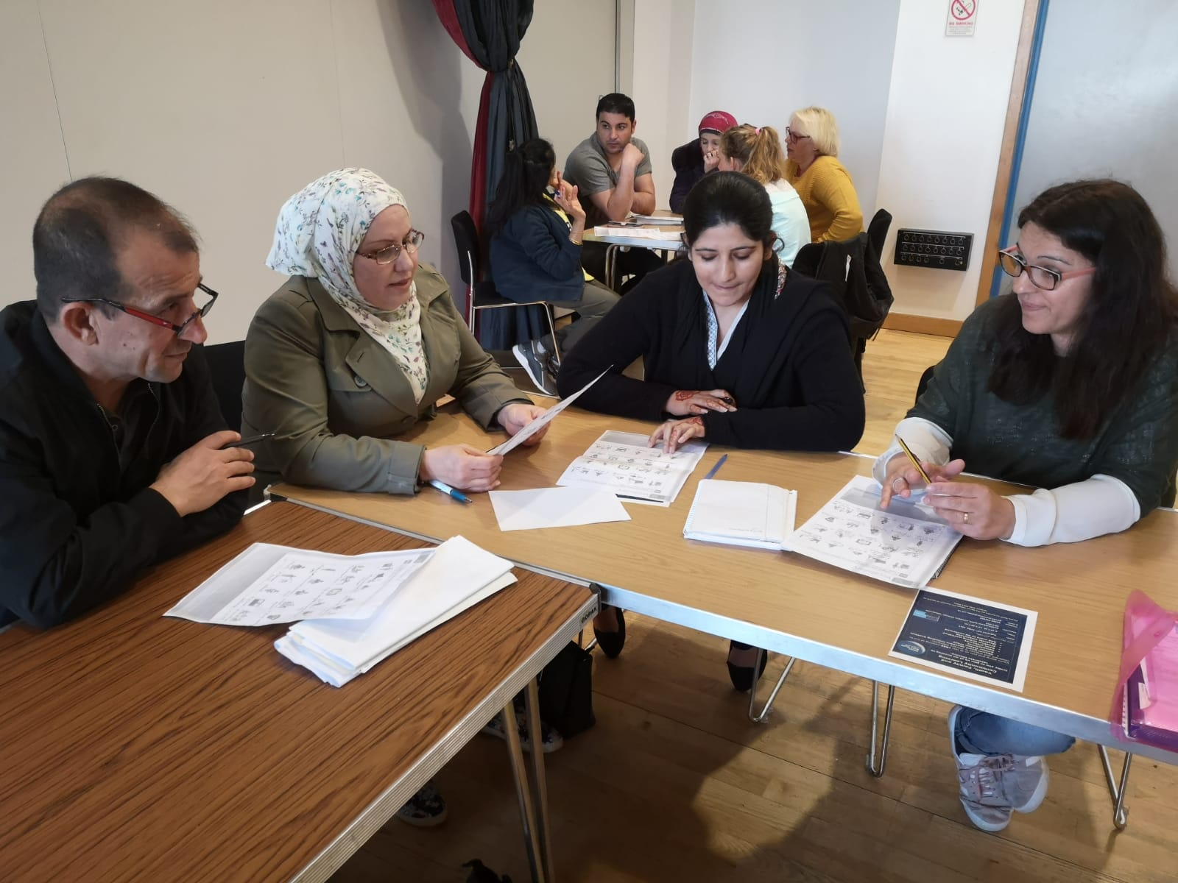
Other Languages (ESOL)

New FREE classes available in your local area –
East Kilbride, Carluke, Rutherglen, Hamilton, Larkhall and Lanark
Youth, Family and Community Learning Service, Hamilton Town House, 102 Cadzow Street, Hamilton ML3 6HH
To make an appointment for an initial assessment please contact Sandra on 01698 452368 or email gw15icshamilton@glow.sch.uk

