Parents of children attending P6 or P7 at non-denominational primary schools associated with Calderglen High School and Duncanrig Secondary School | Our ref: | Consult/EK/2017
 | Your ref:
 | If calling ask for:
 | Phone: | 0303 123 1015
 | Date: | 6/10/2017
Dear Parent

Statutory Consultation Proposal: to change the catchment areas of both Duncanrig Secondary School and Calderglen High School to more effectively balance pupil numbers between the two secondary schools

We are looking for your views on realigning the catchment areas for a proposed new primary school in Jackton. Due to the expansion of housing in the East Kilbride Community Growth Area, the Council have identified the need for a new primary school to be built in the Jackton area.

As a result there is a requirement to determine what the associated secondary school should be for the pupils who will attend this new school. .

We are inviting responses to this consultation by Friday, 1 December 2017.

You are being asked to consider two options. Option one which would see the new school in Jackton re-aligned to Calderglen High with no change for children at Greenhills Primary(current associated secondary school is Duncanrig Secondary) or option two, change the associated secondary school for Greenhills Primary to Calderglen High (with pupils from the new primary school in Jackton attending Duncanrig Secondary)

We are looking for your views on these proposals:-

- OPTION ONE - associate the new, non-denominational primary school planned for the Jackton / East Kilbride Community Growth Area to Calderglen High School; or
- OPTION TWO - change the association of Greenhills Primary School which would mean pupils transfer to Calderglen High School as the local secondary school.

There is a period of Statutory Consultation for this proposal which will commence Monday 9th October 2017 and conclude on Friday 1st December 2017.

A public meeting to which you are invited to discuss the proposals will be held in:

Greenhills Hall, 14 Greenhills Square, East Kilbride G75 8TT
on Tuesday 7th November 2017 at 6pm.

Consultation Process
Consultation is an essential part of the policy making process. It gives us the opportunity to consider your opinion and views on what we are proposing.

Following the closing date, all responses will be analysed and considered and used to inform and influence the decision making process along with a range of other available information and evidence.

When the consultation period has ended, the Council will collate all of the relevant written representations received during the consultation period and oral representations made at the public meeting. Thereafter, the following information will be provided to Education Scotland (formerly HM Inspectorate of Education, HMIe):
- A copy of relevant written representations made to the Council on the proposal (or summary of them if agreed with Education Scotland)
- A summary of oral representations made at the public meeting
- Other relevant documentation, so far as is practicable.

Education Scotland may visit the schools affected by the proposal and will report back to the Council on the educational aspects of the proposal taking account of the above, and in so far that Education Scotland considers them relevant, any written representations made directly to them.

After receiving Education Scotland’s report, the Council will review the proposal taking account of relevant written representations received during the consultation period, oral representations made during the public meeting and Education Scotland’s report. The Council will then prepare and publish a consultation report which will include a recommendation on the proposal and make it available for inspection. The Council will inform any person who made relevant written representations on the proposal of the publication of the report. The consultation report will be published 3 weeks before the proposal it is formally considered by the Executive Committee of the Council.

The consultation proposal document is available from the Council Website and will be made available in the school office and in local Council buildings.

You are encouraged to submit your views by writing to:

South Lanarkshire Council
Education Resources (Central Support Team)
Duncanrig / Calderglen / Greenhills Primary - Consultation Response
Freepost SC05520
Hamilton, ML3 0BR

or by email: education@southlanarkshire.gov.uk

Yours sincerely

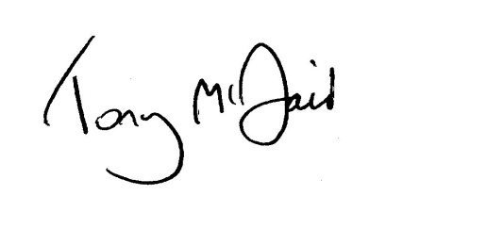
Tony McDaid
Executive Director of Education Resources

Handling your response
All respondents should be aware that the Council is subject to the provisions of the Freedom of Information (Scotland) Act 2002 and would therefore have to consider any request made to it under the Act for information relating to responses made to this consultation exercise.

